**Homework 1**

**Instructions:** Do as many of the problems as you like, but make sure to complete at least two (counting 1 as “three problems”, one for each part). Then the whole class will create a solution jointly (write below, or create a separate file; either is OK). One problem can have multiple solutions, so if your solution is different than the one already posted and you’d like to share yours with others, feel free to add yours. Make sure to separate different solutions to minimize confusion.

1. **a.** Given an integer [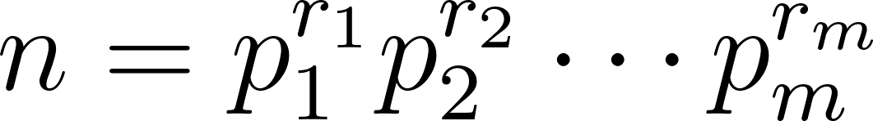](https://www.codecogs.com/eqnedit.php?latex=n%3Dp_1%5E%7Br_1%7Dp_2%5E%7Br_2%7D%5Ccdots%20p_m%5E%7Br_m%7D#0), how many factors does *n* have? (You can consider a special case of [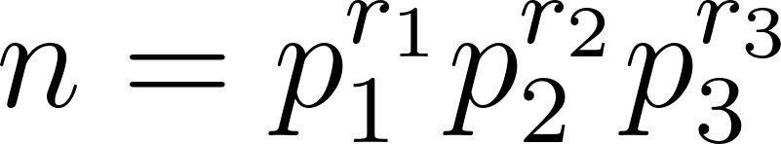](https://www.codecogs.com/eqnedit.php?latex=n%3Dp_1%5E%7Br_1%7Dp_2%5E%7Br_2%7Dp_3%5E%7Br_3%7D#0) if you’d prefer to work with a slightly more concrete case)  
   **b.** Suppose we are looking to find out which *n* have an odd number of factors? What does part **a** tell about *n*?  
   **c.** Now let’s use the other approach of finding factors of a number: pairing a factor *r* with *n/r*. What does this tell us about *n* if *n* has an odd number of factors? Which method was easier in determining this property?
2. If we know that *d* | *a* and *d* | *b*, what other divisibility relations can be concluded? List a few examples and prove the most general conclusion you can make.
3. Prove: If [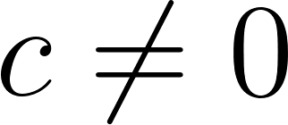](https://www.codecogs.com/eqnedit.php?latex=c%5Cneq%200#0), then [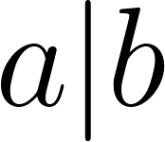](https://www.codecogs.com/eqnedit.php?latex=a%7Cb#0) iff [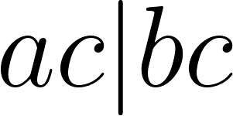](https://www.codecogs.com/eqnedit.php?latex=ac%7Cbc#0). (Iff is short for if and only if.)
4. Prove: If [](https://www.codecogs.com/eqnedit.php?latex=a%7Cb#0) and [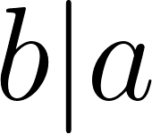](https://www.codecogs.com/eqnedit.php?latex=b%7Ca#0), then [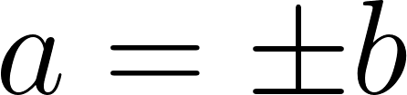](https://www.codecogs.com/eqnedit.php?latex=a%3D%5Cpm%20b#0).
5. Prove: If [](https://www.codecogs.com/eqnedit.php?latex=a%7Cb#0) and [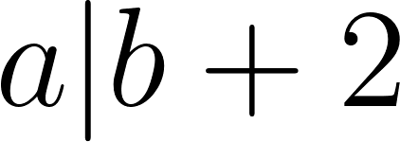](https://www.codecogs.com/eqnedit.php?latex=a%7Cb%2B2#0) and [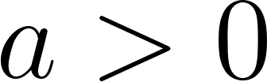](https://www.codecogs.com/eqnedit.php?latex=a%3E0#0), then [](https://www.codecogs.com/eqnedit.php?latex=a%3D1#0) or [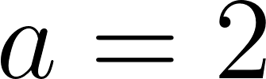](https://www.codecogs.com/eqnedit.php?latex=a%3D2#0).
6. Write a code to check if a|b is true or not. (Once you have a draft, feel free to Google to see if there’s a shorter solution.)